**Engineering Analysis**

1. Introduction:

This report contains details of engineering analyses performed to determine theoretical limitations of the bridge shaker at areas of concern. The team brainstormed ways that the bridge shaker could either underperform or fail to identify these areas of concern. Emphasis was placed on failure modes on the consumer end, rather than failure modes during manufacturing. The main concerns are as follow:

1. The product could disassemble itself at the connection joints under the strain of vibratory loads, with either loosening the connection bolts or completely breaking the bracket.
2. Friction in the shafts could lead to underperforming.
3. Friction on the guiderails could lead to underperforming.
4. The guiderail system might not be strong enough to withstand the forces of the weight at max speed, causing it to break and could cause catastrophic damage to the structure. Material selection is important.
5. The VFD could underperform and output less voltage than is needed for the motor.
6. A fuse might trip and cut power to the system.
7. The motor could overheat.
8. The motor might not produce enough speed to provide adequate force to the bridge.

Once the main concerns were identified, an FMEA was used to determine how deeply each failure mode needed to be addressed. FMEA was chosen due to the complexity and diversity of subsystems, as well as its emphasis on safety issues. The results of the FMEA are shown in the table below, Table 1.

*Table 1: Failure Modes and Effects Analysis*

|  |  |  |  |  |
| --- | --- | --- | --- | --- |
| **Failure Mode** | **Severity** | **Occurrence** | **Detection** | **RPN** |
| A | 10 | 8 | 2 | 160 |
| B | 4 | 6 | 3 | 72 |
| C | 4 | 6 | 3 | 72 |
| D | 10 | 7 | 1 | 70 |
| E | 7 | 4 | 1 | 28 |
| F | 6 | 2 | 3 | 36 |
| G | 7 | 9 | 3 | 189 |
| H | 7 | 7 | 2 | 98 |

The FMEA shows that the greatest concerns are that the product could disassemble itself at the connection joints under the strain of vibratory loads, with either loosening the connection bolts or completely breaking the bracket; the motor could overheat; and the motor might not produce enough speed to provide adequate force to the bridge. The corrective actions for each of these designs will be determined by conducting engineering simulations. For failure mode A (referred to as failure mode #1), a stress analysis is of the 3D printed joints is run to determine deflection caused by the force of vibration. For failure mode H (referred to as failure mode #2), a Simulink model of the motor drive train subsystem is created to test output force, speed, and effect of gear ratio. For failure mode G (referred to as failure mode #3), thermal ports are added to the existing Simulink model to test motor temperature.

1. Analyses performed

Failure mode #1: 3D printed joint failure.

The first analysis performed was the simulated stress on the bracketing assemblies in Fusion 360. This analysis was needed to ensure the 3D printed brackets could withstand the stress of operation, specifically the shear and bending stress. 3D printed brackets were requested by Dr. Austin Downey because they are cheaper than ordering the alternative metal brackets, and he feels that they should be strong enough to hold the frame together. With this information, the team tested the brackets in simulation. The test was done using a few equations from the textbook Machine Elements in Mechanical Design (not all equations used in the simulation will be listed as the team has no way to find every equation used, the general equations for this type of engineering problem are assumed).

(Eq. 1)

(Eq. 2)

(Eq. 3)

(Eq. 4)

*Table 2: Definition of variables for failure mode 1*

|  |  |  |
| --- | --- | --- |
| **Variable symbol** | **Variable name/description** | **Variable units** |
|  | Stress |  |
|  | Strain | N/A |
| E | Young’s Modulus |  |
| L | Change in length |  |
|  | Initial length |  |
| F | Applied force |  |
| A | Area |  |
| M | Bending moment |  |
| I | Moment of inertia | ￼ |
| c | Distance from neutral axis |  |

Knowing these equations and an initial set of parameters based on the orientation of the bracket within the total assembly, the team can constrain and place forces accurately within the simulation. The locked constraints belong to the tops and bottoms of the screw holes in the bracket. The force is comprised of two components: the axial force from the side-to-side movement of the frame and a bending force created by the shaft and weight being supported from the top. Since the software does a comprehensive analysis of the piece and evaluates every section of the bracket, the team cannot give every input condition. The team can supply the image of the constraints placed on the bracket and the forces and their numerical values that were used in the simulation.

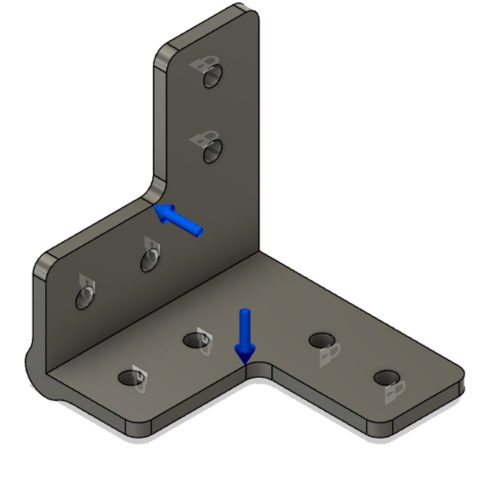

Figure 1: Constraints and loads on 3D printed bracket.

Each blue arrow in Figure 1 is representative of a force applied to the entirety of the inside faces of the bracket. This is to simulate the force applied from the vibrations induced by the motor. The force value is 3000 N, which is estimated from a Simulink model as a good testing range. The working force is expected to be around 500 N with the maximum output in a worst-case scenario at 6000 N. The team has chosen to throttle back the motor and keep it within a safe operating range. This will provide an accurate estimation to the displacement of the material and the stresses it will undergo. Lastly, the safety factor of the brackets will be simulated. Since the brackets are the main failure points identified by the team, they need to be engineered to not only minimally support the forces of the device, but also be able to withstand greater forces than expected. A high safety factor estimation will confirm or deny this hypothesis.

Failure Mode #2: Output Force

The next failure mode will be simulated via Simulink in MATLAB, which models the resulting output force the weight could supply to the system given the motor specifications and gear ratios. The motor specifications are found on the manufacturer’s site [1]. There are several assumptions and unknowns that must be estimated for the model. For instance, exact inertias of the gears, shaft, etc. are assumed to be negligible due to the nature of the model, with the only source of inertia assumed to be from the slider-crank mechanism. The model also assumes an ideal voltage source, and negligible friction effects on all moving parts. For other model inputs in the system, the slider stiffness and damping are also assumed to be negligible. The inertia of the slider-crank can be estimated in the absence of angular acceleration at the instant of maximum torque. The system will be observed as seen in Figure 2.

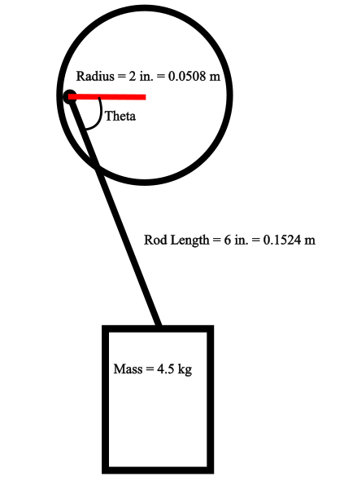

*Figure 2: Free Body Diagram of weight effecting inertia on the system.*

Under negligible angular acceleration, the general equations to solve for the inertia of the crank system, neglecting the disk’s mass are shown below [2].

(Eq. 5)

(Eq. 6)

(Eq. 7)

(Eq. 8)

*Table 3: Definition of Variables for Inertia Equations*

|  |  |  |
| --- | --- | --- |
| **Variable symbol** | **Variable name/description** | **Variable units** |
|  | Torque |  |
|  | Inertia |  |
|  | Angular Acceleration |  |
|  | Disk Radius |  |
|  | Mass |  |
|  | Force |  |
|  | Acceleration due to gravity |  |
|  | Angle in Figure 2 |  |

Through this calculation, a rough estimate for the crank inertia, calculated to be 2.11 , can be plugged into the Simulink model. The simulation is based on fundamental equations for gear and motor systems, shown below [3].

(Eq. 9)

(Eq. 10)

*Table 4: Definition of Variables for Simulink Model Equations*

|  |  |  |
| --- | --- | --- |
| **Variable symbol** | **Variable name/description** | **Variable units** |
|  | Angular velocity |  |
|  | Gear speed |  |
|  | Gear diameter |  |
|  | Number of gear teeth | - |
|  | Torque |  |
|  | Tangential acceleration |  |
|  | Angular acceleration |  |
|  | Radius of disk |  |

These equations govern the calculation of output force on the system, the diagram for the Simulink model can be seen in Figure 3.

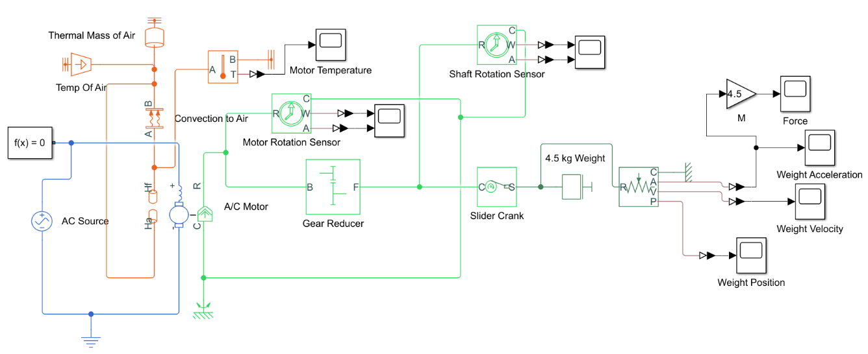

*Figure 3: Simulink Model Diagram for Drive Train System*

The blue portion of Figure 3 represents electrical supply of 230 V of AC voltage to the motor, and the motor itself is defined with specifications depicted on the motor, and from the manufacturer’s website [1]. The light green portion of Figure 3 deals with the rotational portion of the motor, including the gear reduction of 0.5, where the driver hear is twice the size of the driven gear, and a slider-crank which converts rotational motion to translational that is represented in dark green. The translational motion segment has a defined mass of 4.5 kg and ideal translational sensors to track the position, velocity, and acceleration of the weight given a user defined time. This system assumes the AC motor starts at rest. The orange portion of the figure represents thermal effects which are not relevant to this failure mode analysis.

Failure Mode #3: Overheating of the Motor

To determine the temperature effects of the motor in the system, the Simulink model was used via thermal ports built into the Universal Motor interface. The system is open to its surroundings; therefore, the thermal mass of the surrounding air is assumed to be a very large quantity. For the sake of the model, 1,000,000 kg of air was used. The temperature is assumed to on the more extreme end of weather conditions, being 90, or 305.372 K, and the specific heat of air was input into the system, 1 . Finally, the main source of heat transfer in the system is convection to the surrounding air, and the governing equations which dictate this are shown below [4].

(Eq. 11)

*Table 5: Definition of Variables for Heat Transfer Equation*

|  |  |  |
| --- | --- | --- |
| **Variable symbol** | **Variable name/description** | **Variable units** |
|  | Convection heat transfer |  |
|  | Heat transfer coefficient |  |
|  | Surface area in contact with air |  |
|  | Surface temperature of motor |  |
|  | Temperature of surrounding air |  |

While most of these variables are quite easy to estimate, one which poses a particular challenge to obtain is the heat transfer coefficient, . This is due to the fact it is dependent on a multitude of factors, such as turbulent and laminar air flow conditions, thermal conductivity of the material, etc. For this project, conditions will vary in application, and the heat transfer coefficient is defined based on the flow of surrounding fluid being consistent, which in our case it is not. For the worst-case scenario, the heat transfer coefficient is assumed to be 5 , which, given the high thermal conductivity of the motor's metal body, is an appropriate approximation. The area of heat transfer is assumed to be 0.25 . The thermal effects can be seen below in Figure 4.

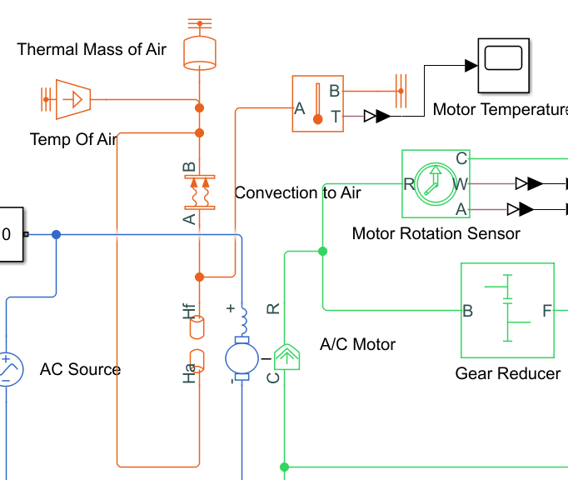

*Figure 4: Thermal effects on the motor*

This orange portion model shows the heat transfer of the motor, with it receiving and giving off heat to its surroundings. The temperature of the surface of the motor is monitored using an ideal temperature sensor.

1. Modeling/Analysis Results:

**Failure Mode #1**: Stress Max: 17.91 MPa, Displacement Max: 0.9643 mm, Safety Factor Min: 1.675

Figure 2: Stress simulation results.

The first modeling results analyzed were the stresses in the bracket. These results show promising signs as the maximum stress induced on the part was approximately 17.91 MPa. The National Library of Medicine says that the yield strength for polylactic acid, 3D printing plastic, is 60 MPa [5]. The bracket is well within the safe zone of this material and should be suitable for frame support. The stress maximums were located around the screw holes which was as expected.

Figure 3: Displacement simulation results.

The second model analyzed was the displacement model for the material. This model indicates that the material will yield 0.9643 mm for the 3000 N force that will be applied. This minimal displacement will take place at two locations. Both locations are on the top of the bracket furthest away from a locked constraint or another support, which was expected. After printing and attaching the bracket to the frame, it was decided for stability purposes that an additional L-bracket should be added to the inside of the frame as to resist the flexure of the unsecured sides of the extruded aluminum.

Figure 4: Safety Factor simulation results.

Lastly, for this failure mode, the final area explored was the safety factor of the bracket. The lowest safety factor takes place near the edge of the screw hole closest to where the maximum displacement takes place and where the maximum stress is located. With a safety factor of 1.675 the design is considered mildly safe but should have more material added to help better protect against failure. For these reasons, this area will be watched during testing. The safety factor for this area will increase with the latest adaptation to the design, which is to make was to add rectangular guiding pieces along the same axis as the screw holes. This will allow the bracket to fit snugly in the extruded aluminum pieces and mechanically join the two pieces together more adequately. From the modeling performed on the brackets, the group was able to determine that the brackets should not fail. They have a safety factor above 1 and are expected to increase further, experience stress well below the yield stress, and have a displacement of less than a millimeter. For these reasons the group has decided to move forward with 3D printing the brackets for the frame connections.

**Failure Mode #2**:

Input: 230 V; 100 seconds

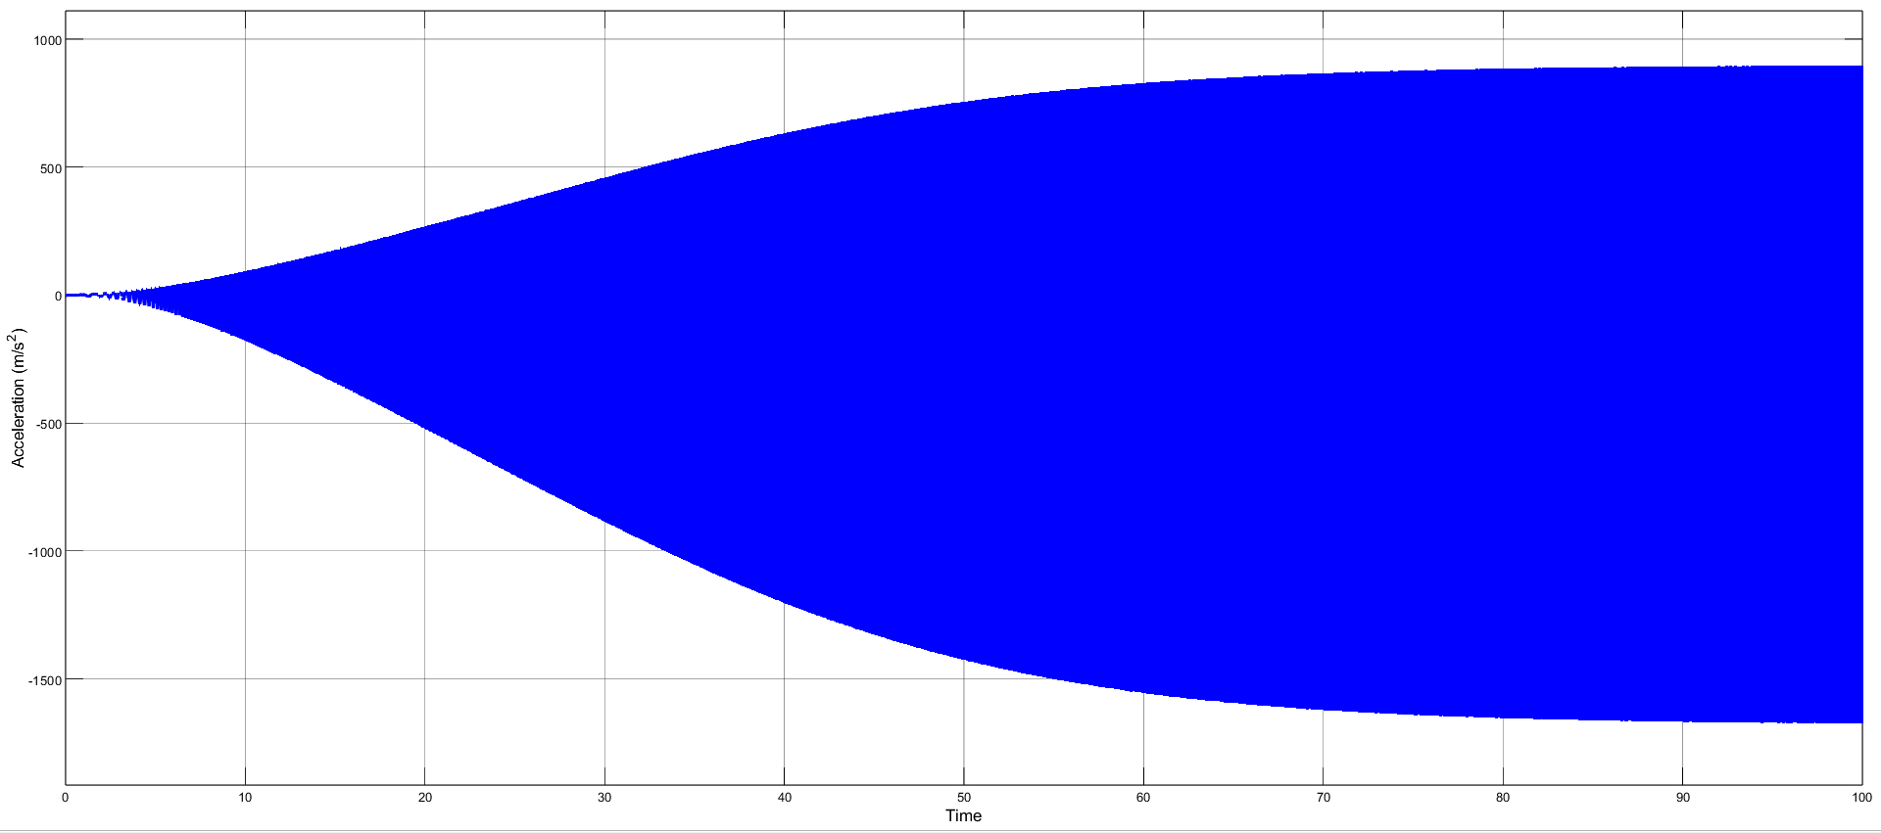*Figure 8: Acceleration of weight for 100 seconds.*

Input: 230 V; 20 seconds

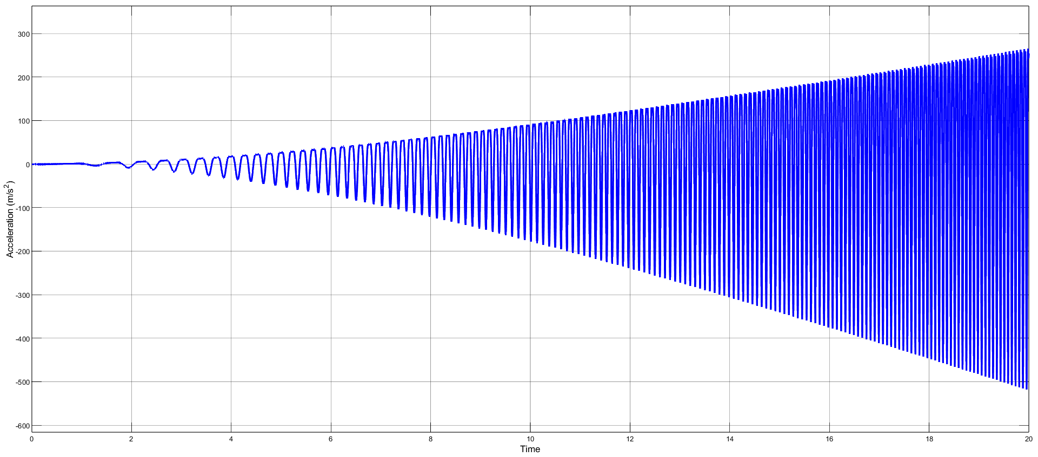*Figure 9: Acceleration results for 20 seconds.*

As seen in the results above in Figure 8, the acceleration when the motor reaches a steady state reaches well above 1500 , which would output a force of well over 6,000 N, assuming a mass weight of 4.5 kg. The positive and negative values represent the acceleration of the weight moving upward and downward. The downward acceleration is higher due to effects of gravity. Models are not perfect, and reaching this amount of acceleration could output forces well over the amount the frame could stand before failing. Therefore, it is necessary that the motor is throttled back to the design specifications to reach the amount of force necessary for observation in the vibration analysis. The assumptions and imperfections of the model will also make this level of acceleration highly optimistic to reach. However, the acceleration of the weight reaching such high values is useful for this project, as it can be inferred that the shaker will at least be able to reach this project’s target value of 500 N.

**Failure Mode #3:**

Input: 230 V; 1,000 seconds; 305.372 K Air Temperature

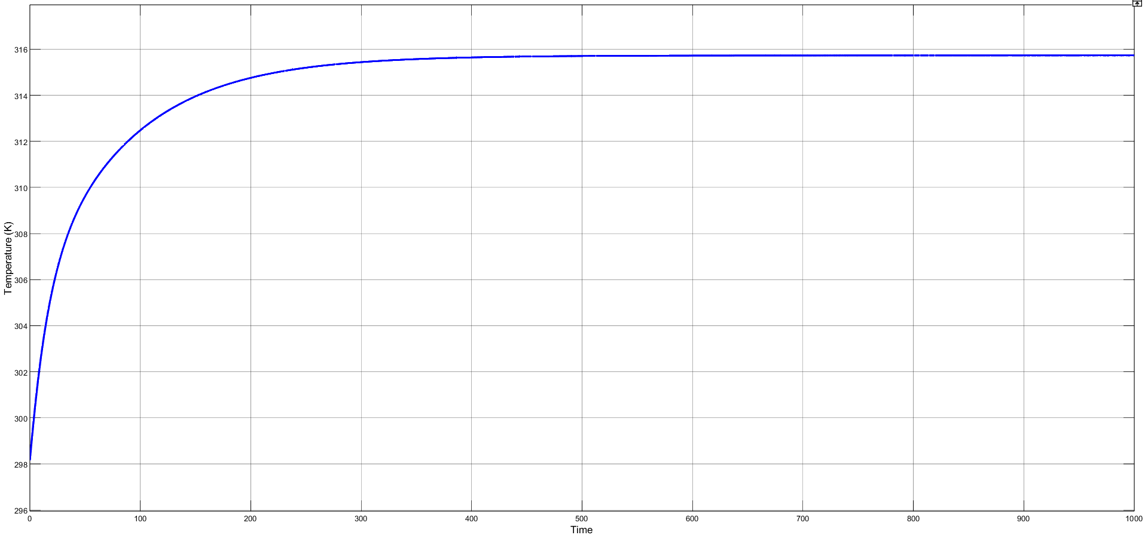*Figure 10: Temperature of the motor in operation for 1000 seconds, exposed to 90.*

As shown in Figure 10, the motor is subjected to 105.372 K or 90 heat through operation. The temperature of the motor rises and levels off at steady state without reaching extreme temperatures, as the maximum temperature reached is less than 316 K, or 109.13. This is well within safe operating temperatures for AC motors, and no active cooling is necessary to provide additional heat transfer. This simulation is also performed for 1,000 seconds, which is much higher than the expected time the shaker will be in use to collect data.

1. Conclusion and/or recommendations:

In this report, the first analysis performed was a simulation of the stress on the bracketing assemblies in Fusion 360 to test the strength of 3D printed brackets, which were requested by our project sponsor for their cost effectiveness. The main concern of these brackets was whether the plastic could handle the shear and bending stress, and the test was done using equations for the textbook “Machine Elements in Mechanical Design.” Based on the analysis done, the brackets should not fail, indicating that the brackets are adequate as is. The second analysis consisted of a SIMULINK model run through MATLAB to determine the output force of the motor. The results showed that the motor reaches an acceleration above 1500 m/s^2, which translates to a force of over 6,000 N with a mass weight of 4.5 kg. The downward acceleration is higher because of gravity. The high level of acceleration could result in forces beyond what the frame can handle, so the motor must be adjusted to the design specifications for the vibration analysis. The results are optimistic, but the acceleration of the weight still demonstrates the shaker’s ability to reach the target value of 500 N for this project. Based on the model, the motor is adequate and will not need to be replaced. Our third analysis was a SIMULINK model to determine the effects of the temperature of the motor during use. In the model, the motor reached a temperature of 105.372 K during operation. The temperature rises to 316 K, but it does not exceed it. That is within the safe operating range for this motor, so no additional cooling is needed. The model indicates that the temperature of the motor will not cause it to need to be replaced.

1. References

[1] *Lafert HE90LE4 AC Motor 3PH 2HP 1735rpm 230/460V-AC*. Surplus and Used Industrial Parts and Equipment. (n.d.). Retrieved February 6, 2023, from <https://www.nriparts.com/products/lafert-he90le4-ac-motors/476553>

[2] Vedantu. (2022, November 29). *Relation between torque and moment of inertia*. VEDANTU. Retrieved February 6, 2023, from <https://www.vedantu.com/physics/relation-between-torque-and-moment-of-inertia>

[3] Admin. (2022, October 20). *Gear train : Gear ratio, torque and speed calculations*. SMLease Design. Retrieved February 6, 2023, from <https://www.smlease.com/entries/mechanism/gear-train-gear-ratio-torque-and-speed-calculation/#:~:text=the%20input%20shaft.-,Gear%20Ratio%20and%20Torque,input%20torque%20with%20gear%20ratio>.

[4] Bergman, T. L., Lavine, A. S., Incropera, F. P., & Dewitt, D. P. (2016). *Fundamentals of heat and mass transfer*. John Wiley.

[5] Travieso-Rodriguez, J. A., Jerez-Mesa, R., Llumà, J., Traver-Ramos, O., Gomez-Gras, G., & Roa Rovira, J. J. (2019, November 22). *Mechanical properties of 3D-printing polylactic acid parts subjected to bending stress and fatigue testing*. Materials (Basel, Switzerland). Retrieved February 6, 2023, from <https://www.ncbi.nlm.nih.gov/pmc/articles/PMC6926899/>